C Programming — Assignment 1
Modules 1–6 | Platform Questions | Screenshot-ready submission document
Student name: Utkarsh Mathur Roll no.: 26CSU199

Module 1 — Input/output, variables and basic arithmetic

Question 1: Read from STDIN, Write to STDOUT
Platform: HackerEarth
Problem link: https://www.hackerearth.com/practice/basic-programming/input-output/basics-of-input-output/practice-problems/algorithm/io-exercise/
C Code
#include <stdio.h>
int main()
{
char s[1000];
scanf("%999s", s);
printf("%s\n", s);
return 0;
}
Successful Submission Screenshot
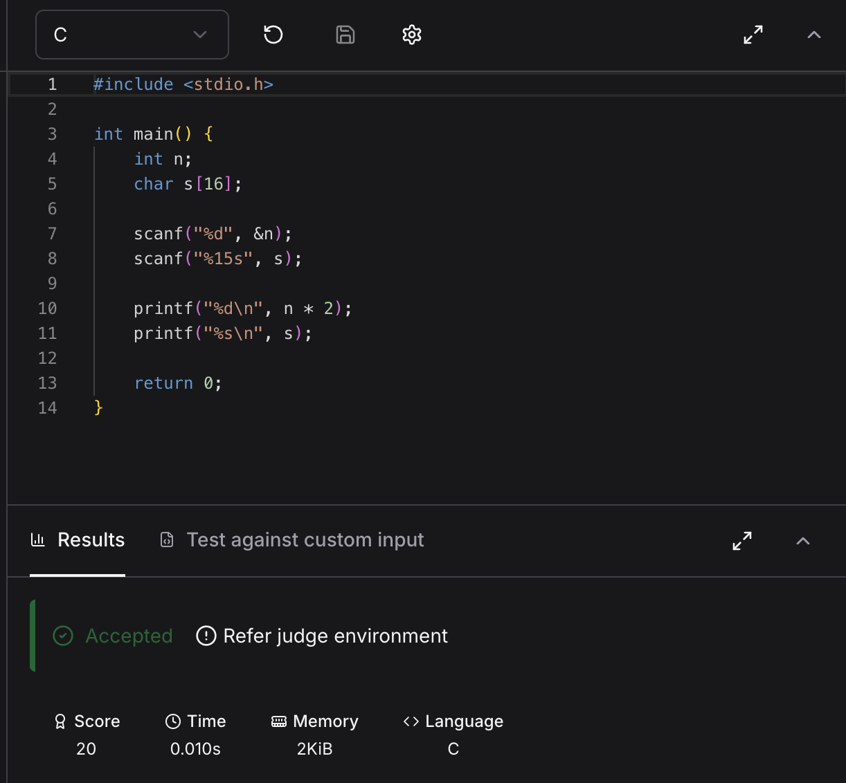

Question 2: Solve Me First
Platform: HackerRank
Problem link: https://www.hackerrank.com/challenges/solve-me-first/problem
C Code
#include <stdio.h>
int main()
{
int a, b;
scanf("%d %d", &a, &b);
printf("%d\n", a + b);
return 0;
}
Successful Submission Screenshot
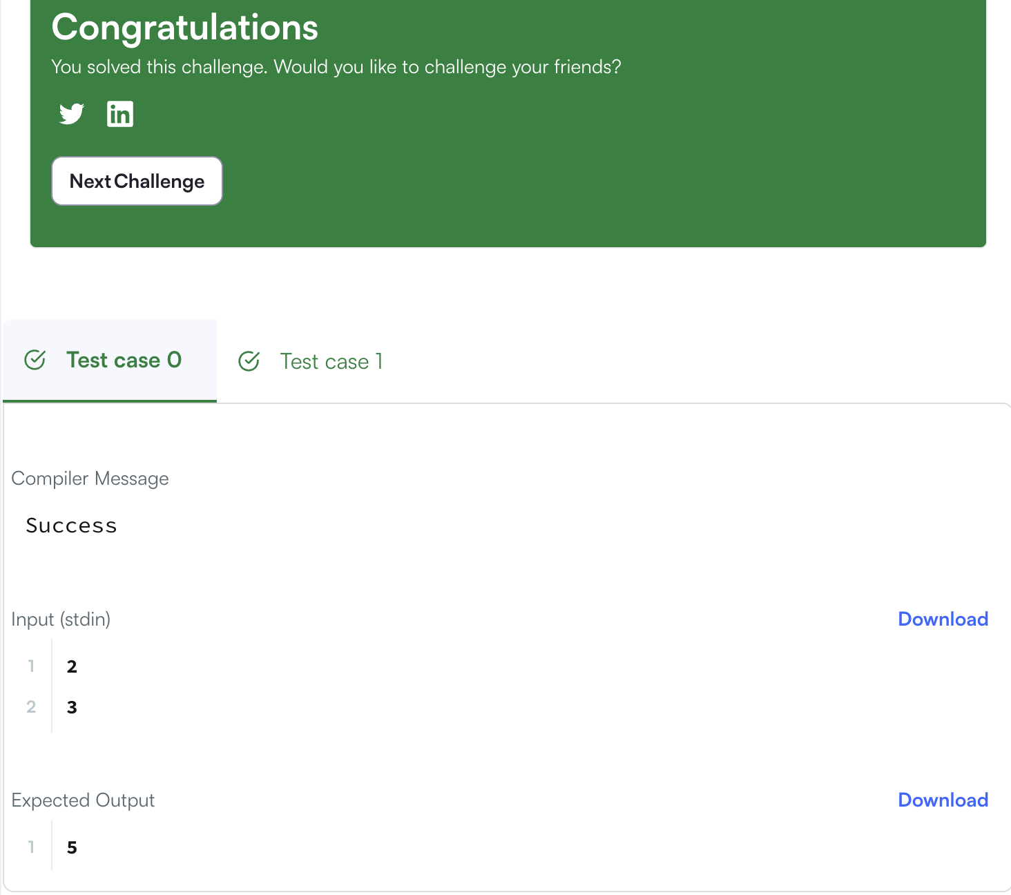

Question 3: 2235 — Add Two Integers
Platform: LeetCode
Problem link: https://leetcode.com/problems/add-two-integers/
C Code
int sum(int num1, int num2)
{
return num1 + num2;
}
Successful Submission Screenshot
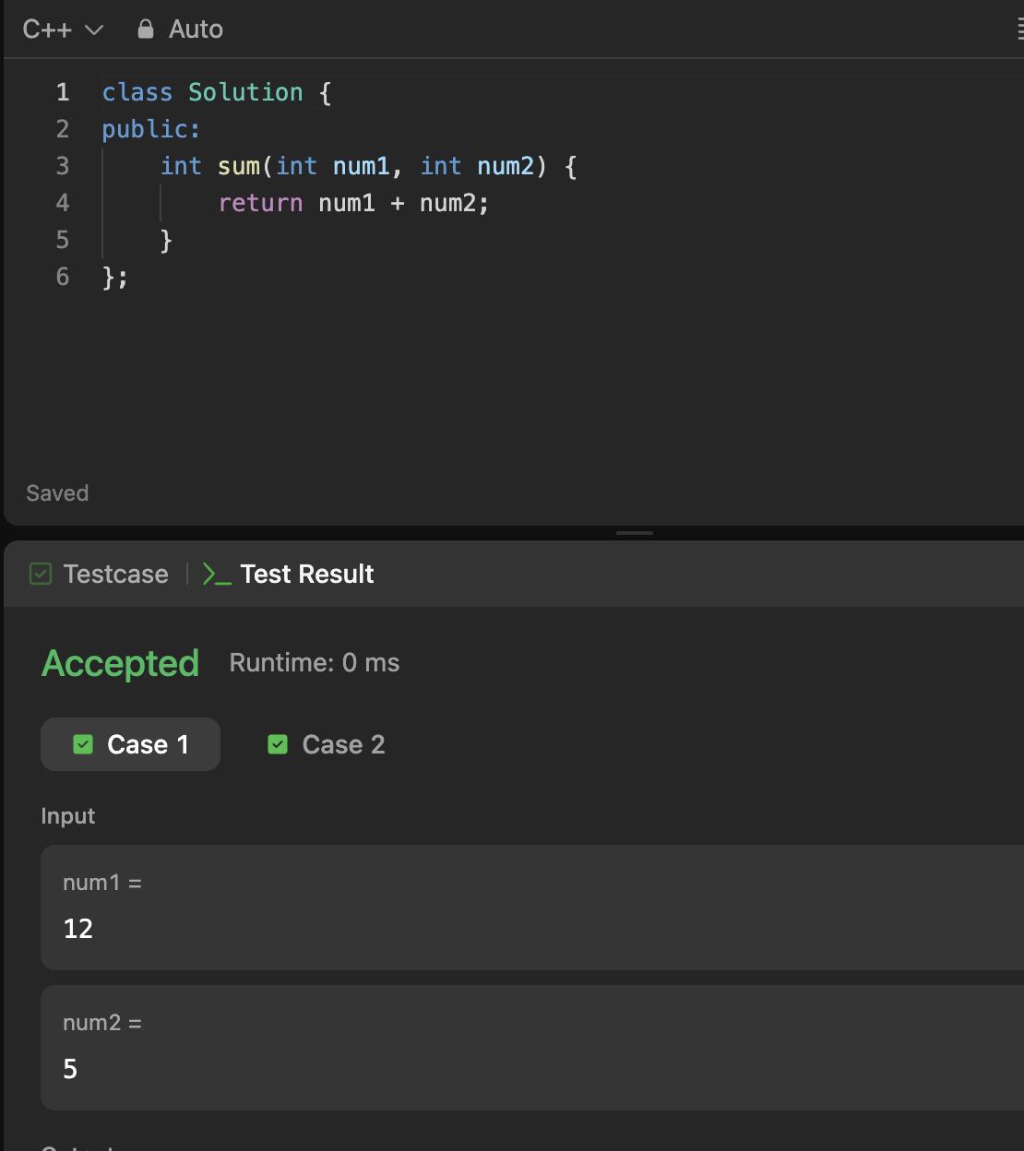

Question 4: 2651 — Calculate Delayed Arrival Time
Platform: LeetCode
Problem link: https://leetcode.com/problems/calculate-delayed-arrival-time/
C Code
int findDelayedArrivalTime(int arrivalTime, int delayedTime)
{
return (arrivalTime + delayedTime) % 24;
}
Successful Submission Screenshot
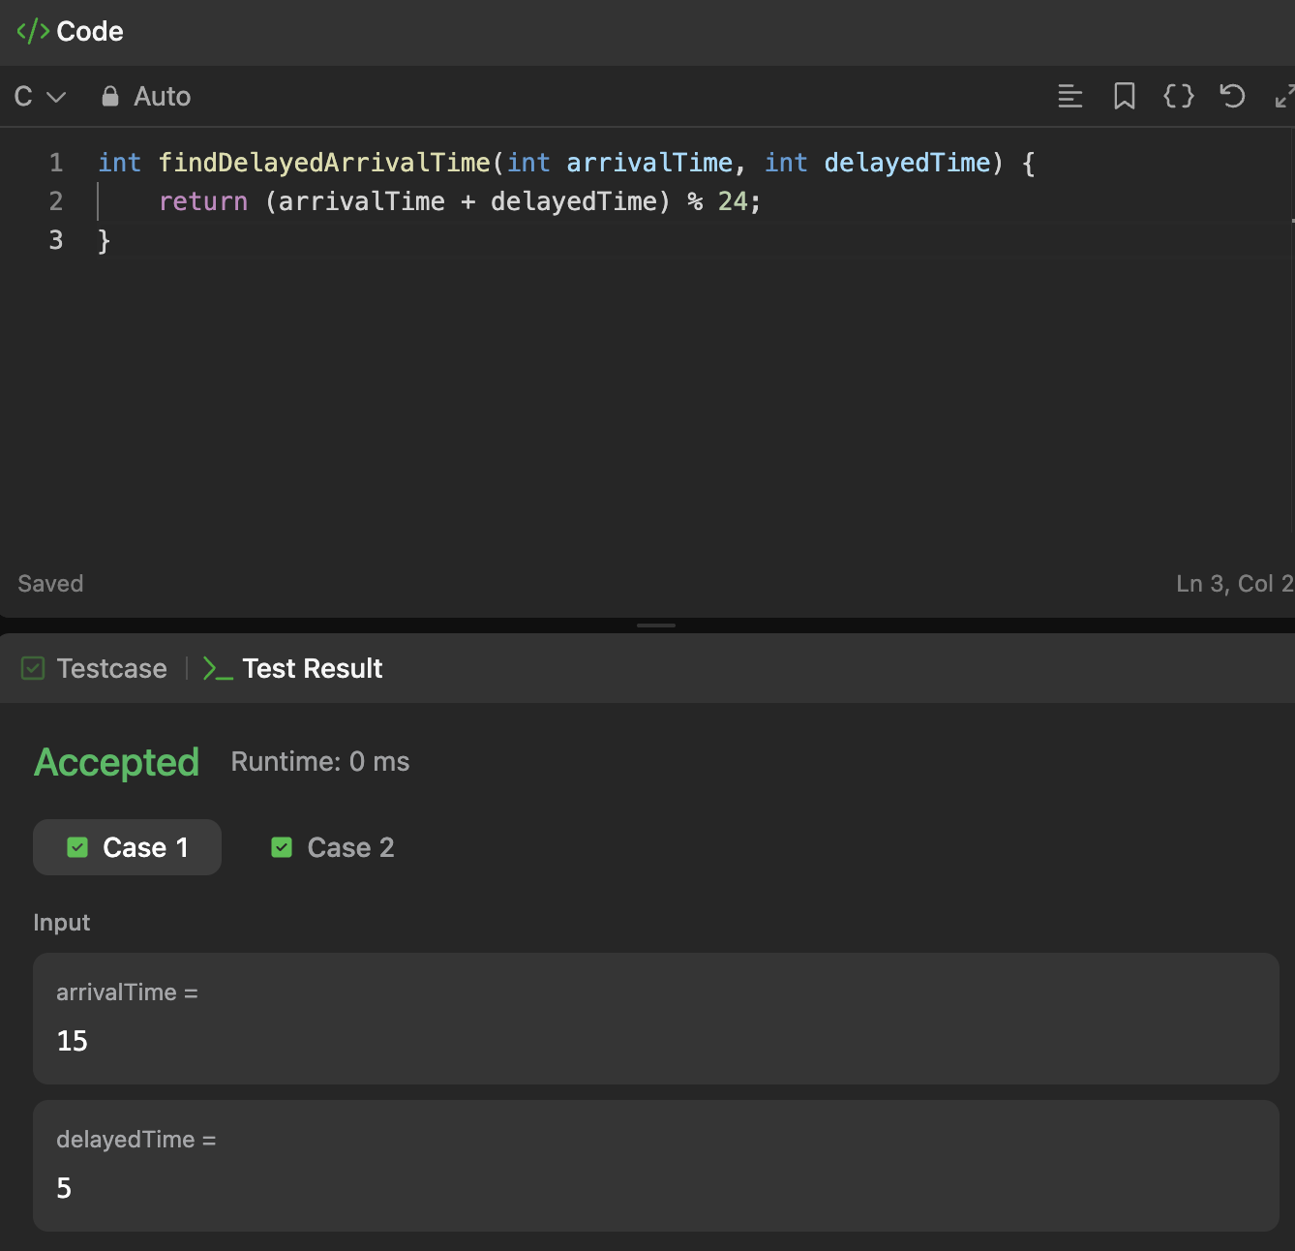

Question 5: 2739 — Total Distance Traveled
Platform: LeetCode
Problem link: https://leetcode.com/problems/total-distance-traveled/
C Code
int distanceTraveled(int mainTank, int additionalTank)
{
int distance = 0;
while(mainTank >= 5 && additionalTank > 0)
{
mainTank -= 4;
additionalTank--;
}
distance = mainTank * 10;
return distance;
}
Successful Submission Screenshot
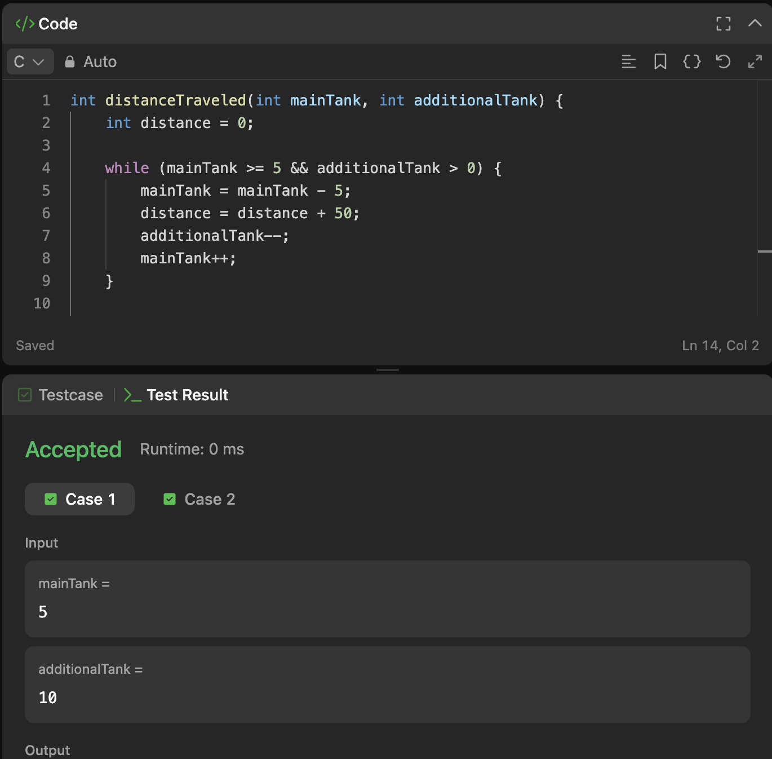

Module 2 — Conditional statements and operators

Question 1: Conditional Statements in C
Platform: HackerRank
Problem link: https://www.hackerrank.com/challenges/conditional-statements-in-c/problem
C Code
#include <stdio.h>
int main()
{
int n;
scanf("%d", &n);
if(n == 1) printf("one");
else if(n == 2) printf("two");
else if(n == 3) printf("three");
else if(n == 4) printf("four");
else if(n == 5) printf("five");
else if(n == 6) printf("six");
else if(n == 7) printf("seven");
else if(n == 8) printf("eight");
else if(n == 9) printf("nine");
else printf("Greater than 9");
return 0;
}
Successful Submission Screenshot


Question 2: 2413 — Smallest Even Multiple
Platform: LeetCode
Problem link: https://leetcode.com/problems/smallest-even-multiple/
C Code
int smallestEvenMultiple(int n)
{
if(n % 2 == 0) return n;
return 2 * n;
}
Successful Submission Screenshot
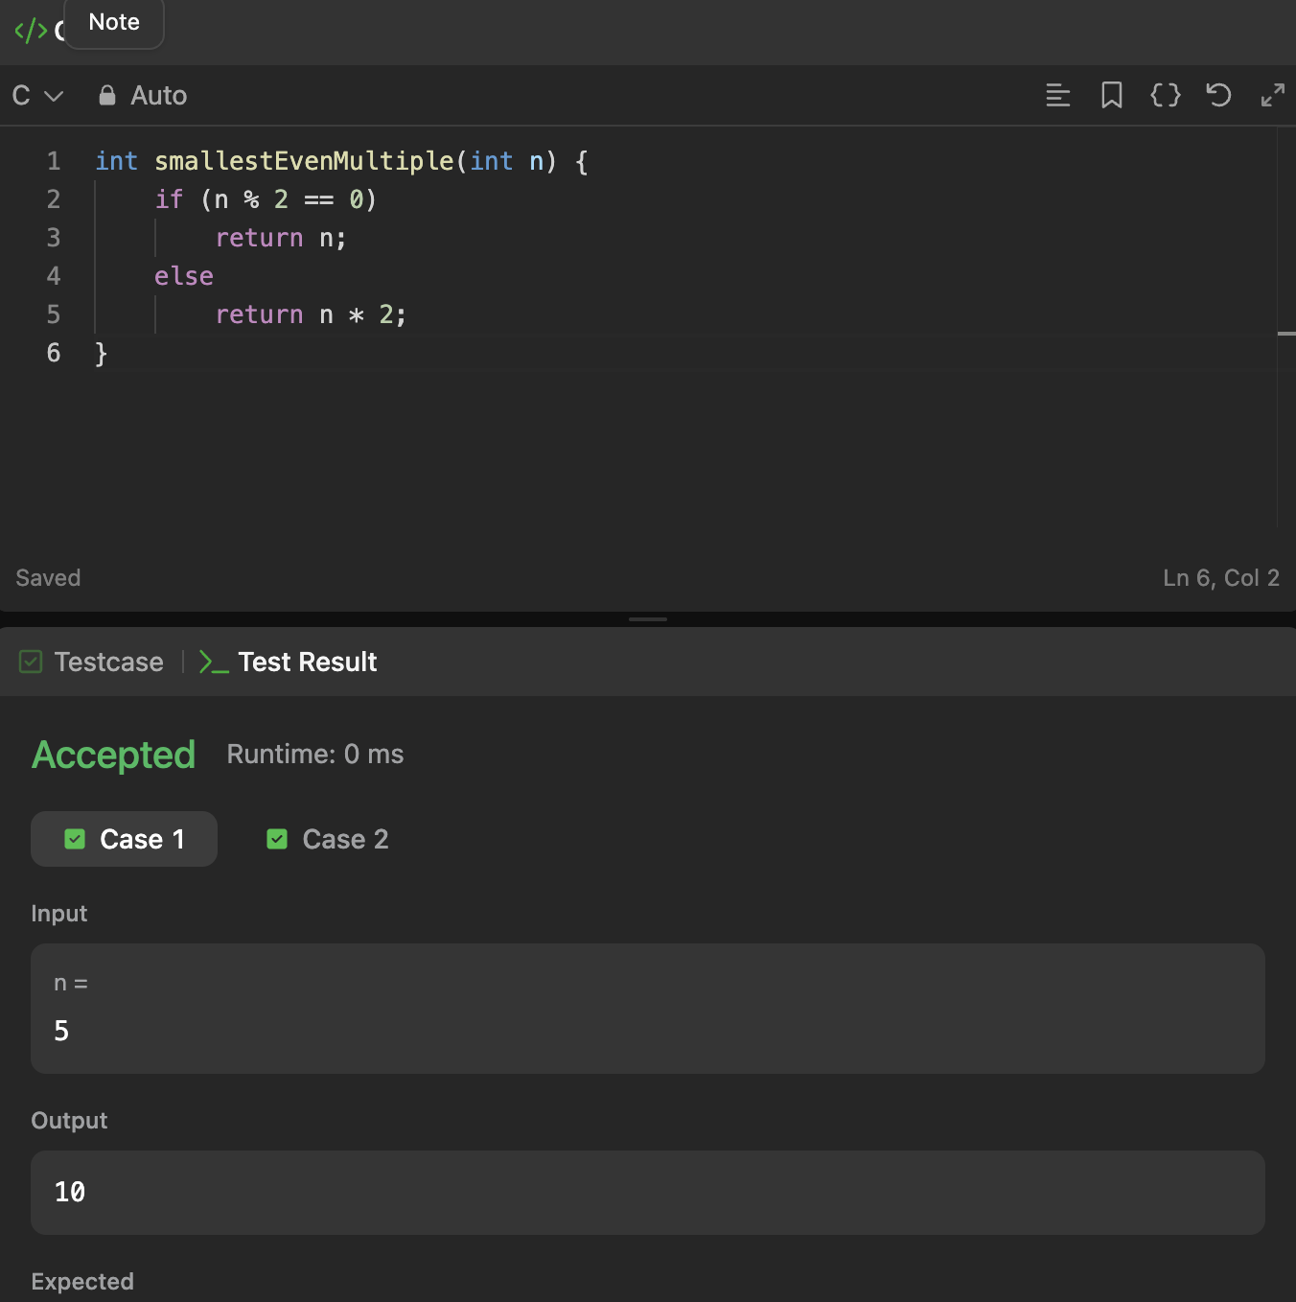

Question 3: Grading Students
Platform: HackerRank
Problem link: https://www.hackerrank.com/challenges/grading/problem
C Code
int* gradingStudents(int grades_count, int* grades, int* result_count)
{
*result_count = grades_count;
for(int i = 0; i < grades_count; i++)
{
if(grades[i] >= 38 && 5 - grades[i] % 5 < 3)
grades[i] += 5 - grades[i] % 5;
}
return grades;
}
Successful Submission Screenshot
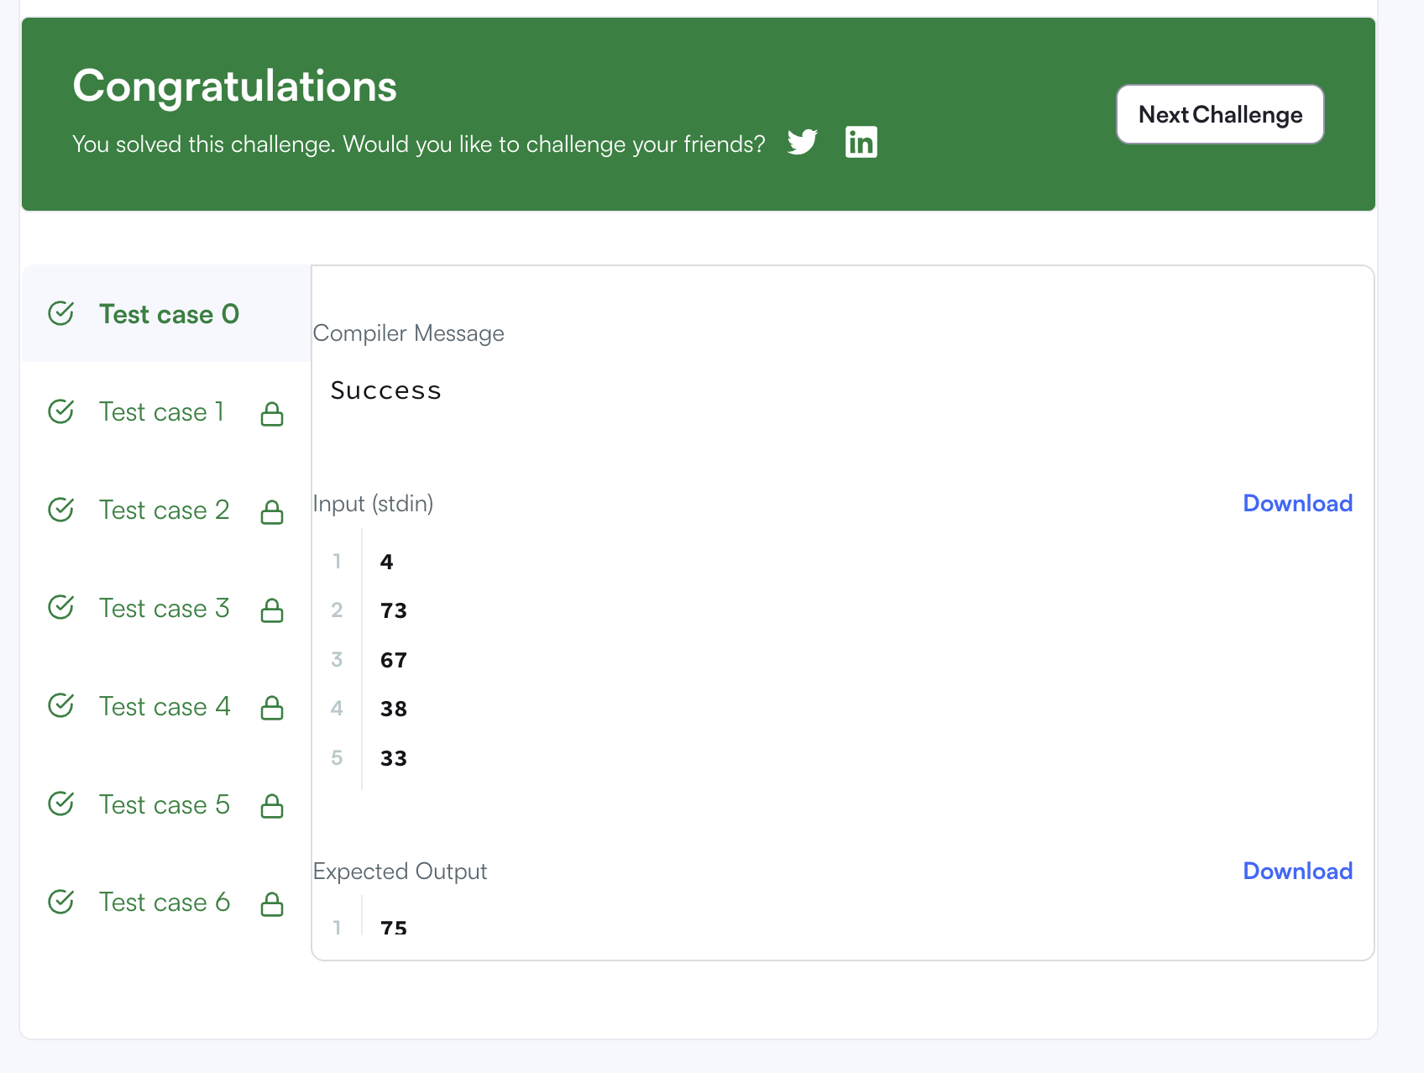

Question 4: Roy and Profile Picture
Platform: HackerEarth
Problem link: https://www.hackerearth.com/practice/basic-programming/input-output/basics-of-input-output/practice-problems/algorithm/roy-and-profile-picture/
C Code
#include <stdio.h>
int main()
{
int l, n, w, h;
scanf("%d %d", &l, &n);
while(n--)
{
scanf("%d %d", &w, &h);
if(w < l || h < l) printf("UPLOAD ANOTHER\n");
else if(w == h) printf("ACCEPTED\n");
else printf("CROP IT\n");
}
return 0;
}
Successful Submission Screenshot
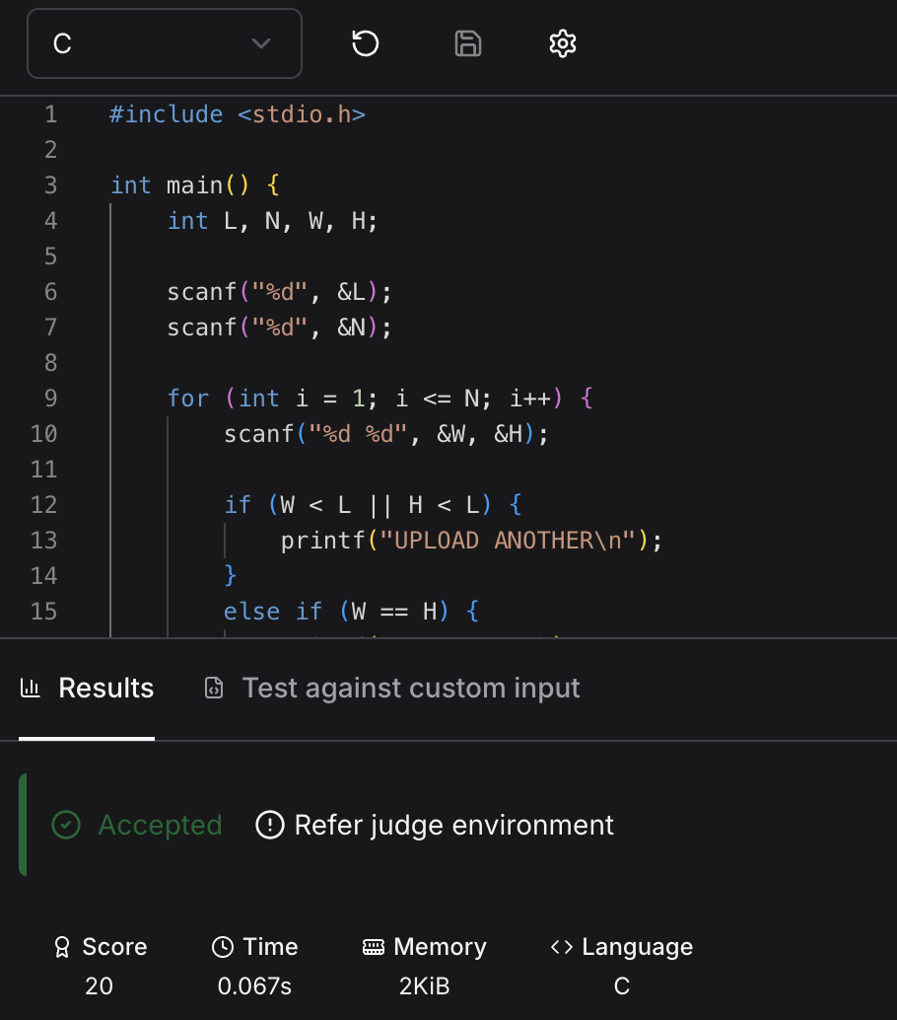

Question 5: FizzBuzz
Platform: HackerRank
Problem link: https://www.hackerrank.com/challenges/fizzbuzz/problem
C Code
#include <stdio.h>
void fizzBuzz(int n)
{
for(int i = 1; i <= n; i++)
{
if(i % 15 == 0) printf("FizzBuzz\n");
else if(i % 3 == 0) printf("Fizz\n");
else if(i % 5 == 0) printf("Buzz\n");
else printf("%d\n", i);
}
}
Successful Submission Screenshot
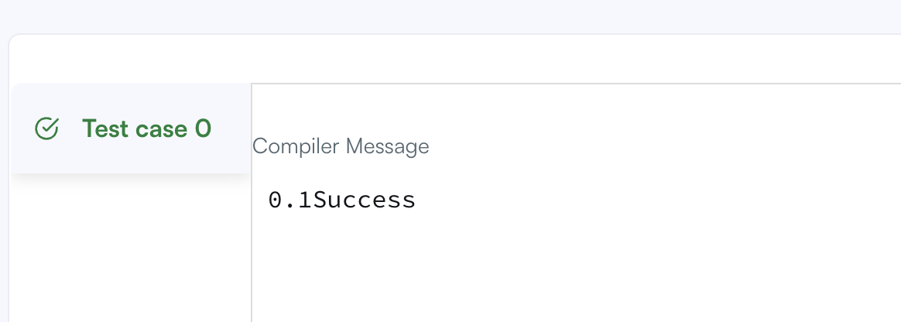

Module 3 — Loops and repeated computation

Question 1: For Loop in C
Platform: HackerRank
Problem link: https://www.hackerrank.com/challenges/for-loop-in-c/problem
C Code
#include <stdio.h>
int main()
{
int a, b;
scanf("%d %d", &a, &b);
char *names[] = {"one", "two", "three", "four", "five", "six", "seven", "eight", "nine"};
for(int i = a; i <= b; i++)
{
if(i >= 1 && i <= 9) printf("%s\n", names[i - 1]);
else if(i % 2 == 0) printf("even\n");
else printf("odd\n");
}
return 0;
}
Successful Submission Screenshot
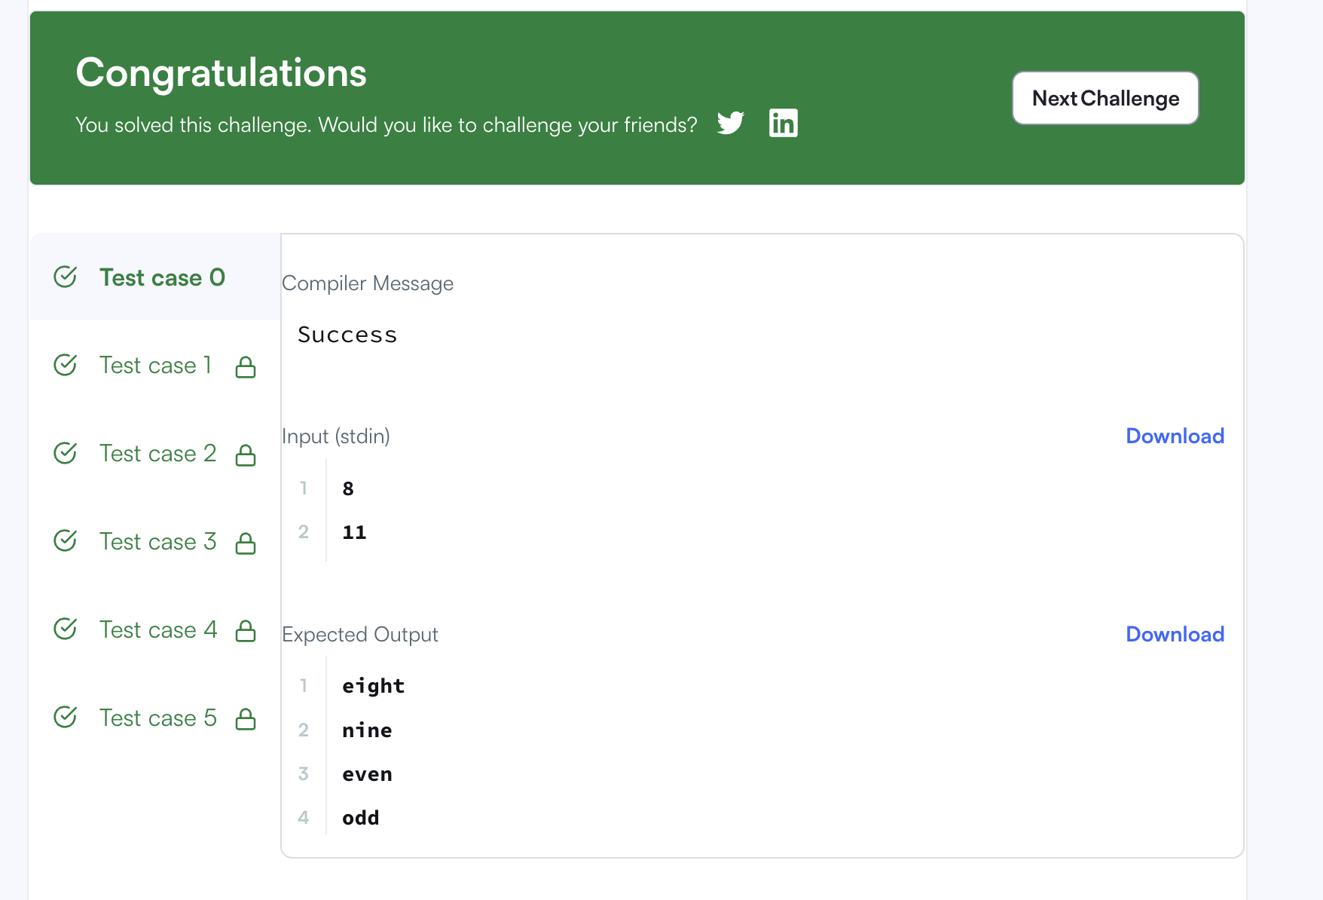

Question 2: 1342 — Number of Steps to Reduce a Number to Zero
Platform: LeetCode
Problem link: https://leetcode.com/problems/number-of-steps-to-reduce-a-number-to-zero/
C Code
int numberOfSteps(int num)
{
int steps = 0;
while(num > 0)
{
if(num % 2 == 0) num = num / 2;
else num--;
steps++;
}
return steps;
}
Successful Submission Screenshot
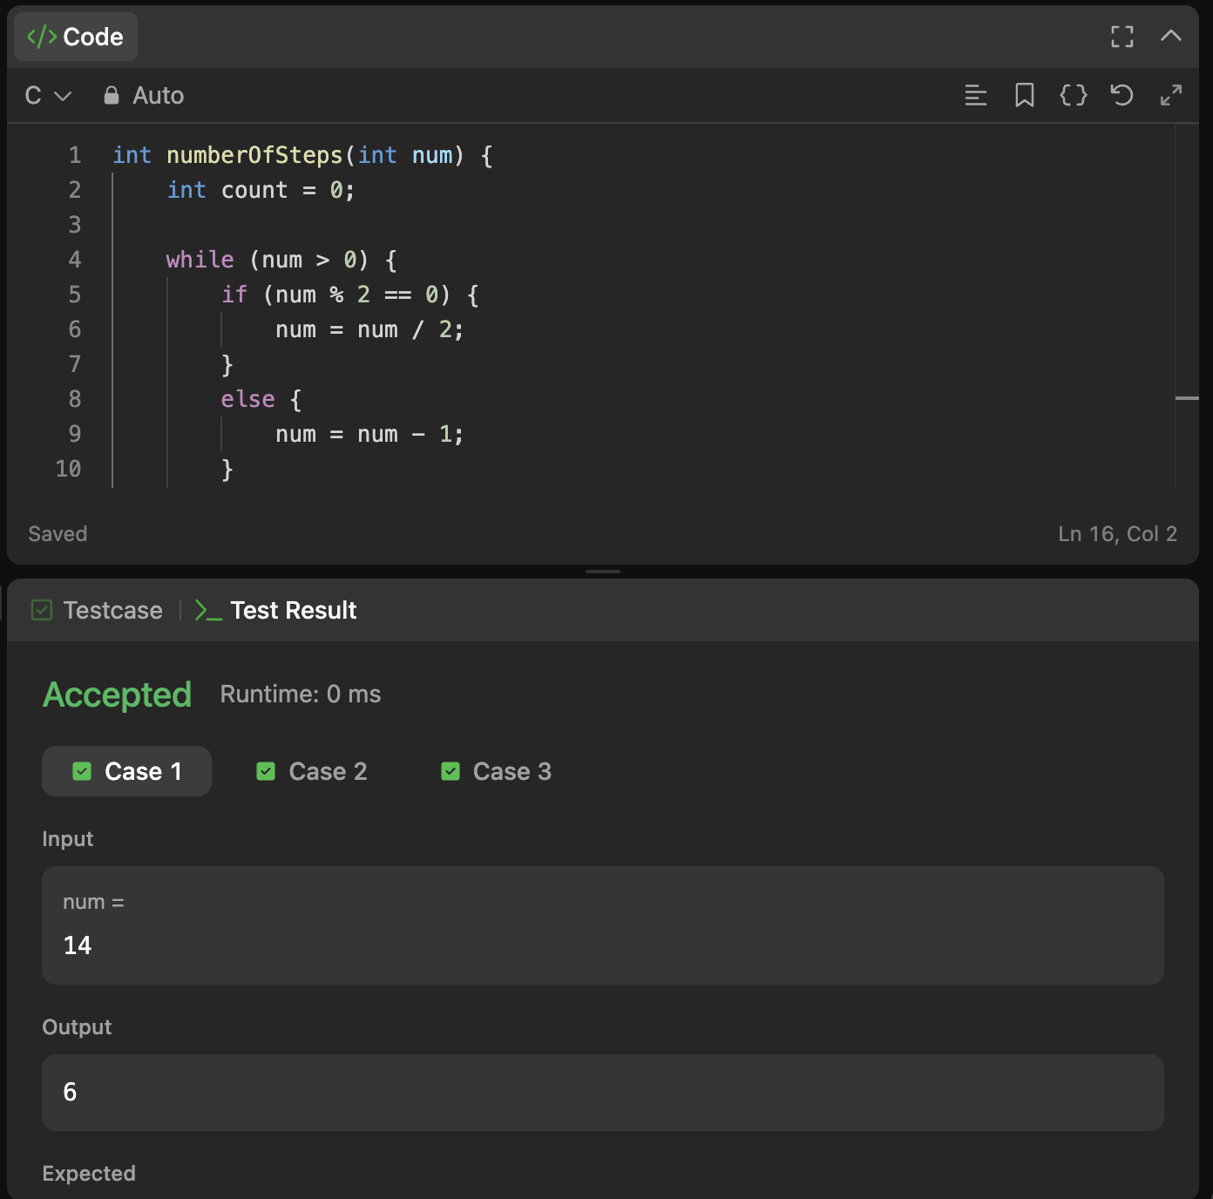

Question 3: 2169 — Count Operations to Obtain Zero
Platform: LeetCode
Problem link: https://leetcode.com/problems/count-operations-to-obtain-zero/
C Code
int countOperations(int num1, int num2)
{
int count = 0;
while(num1 != 0 && num2 != 0)
{
if(num1 >= num2) num1 -= num2;
else num2 -= num1;
count++;
}
return count;
}
Successful Submission Screenshot
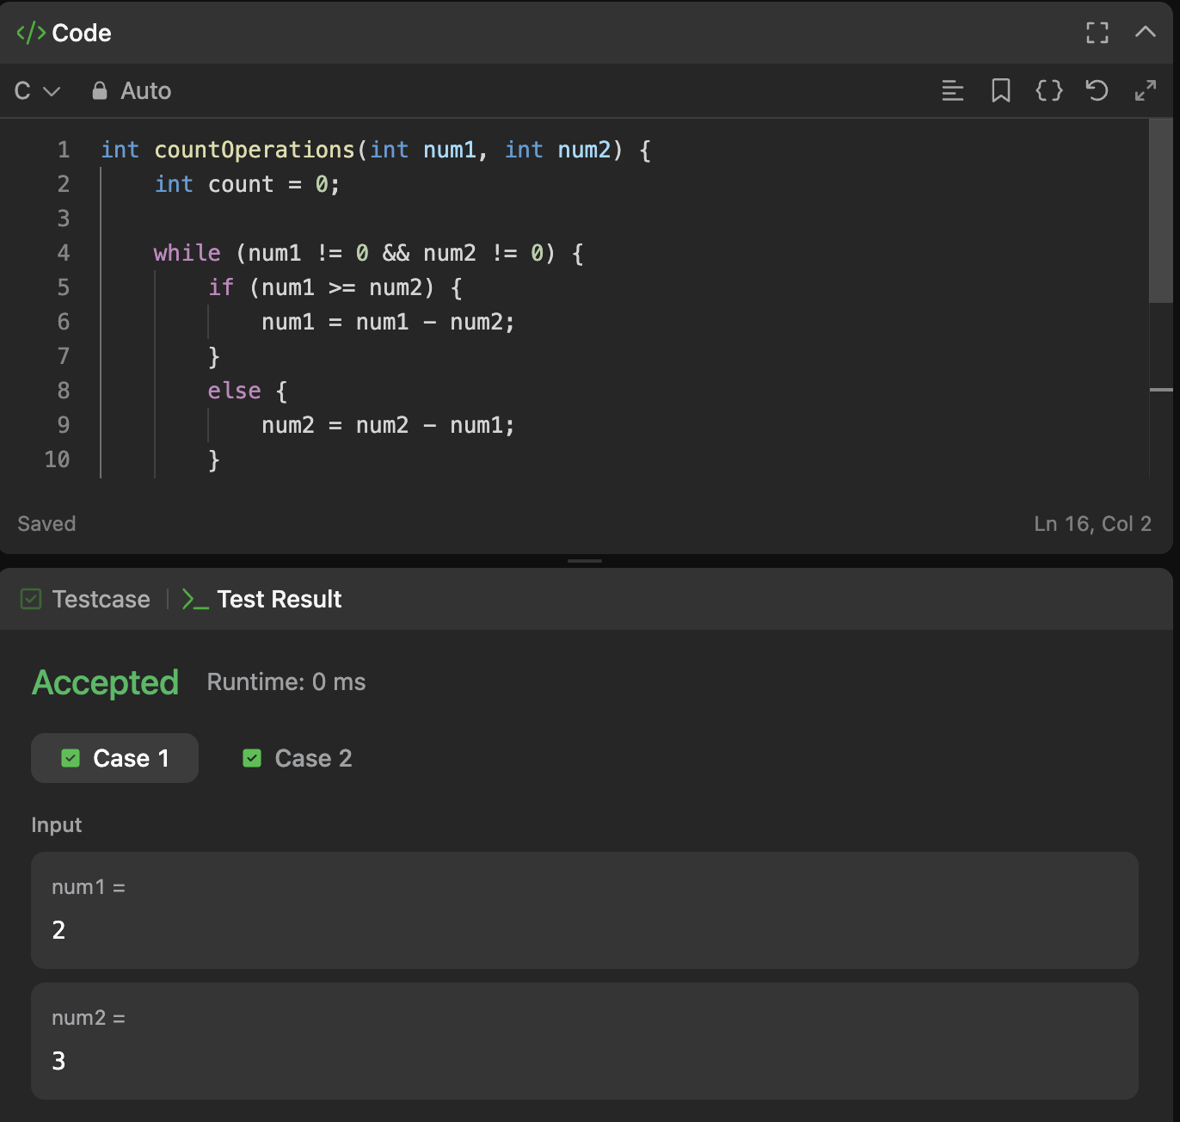

Question 4: 1523 — Count Odd Numbers in an Interval Range
Platform: LeetCode
Problem link: https://leetcode.com/problems/count-odd-numbers-in-an-interval-range/
C Code
int countOdds(int low, int high)
{
return (high + 1) / 2 - low / 2;
}
Successful Submission Screenshot
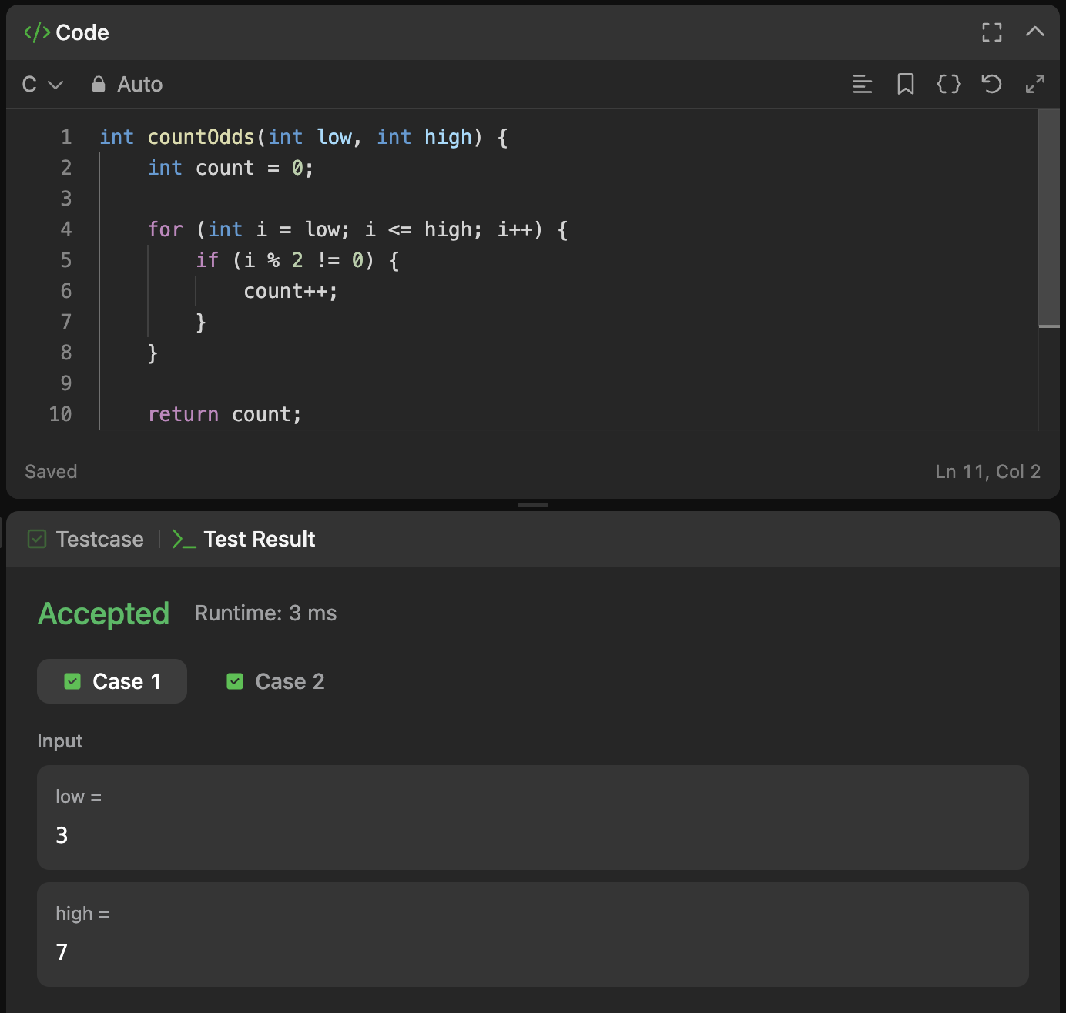

Question 5: 2652 — Sum Multiples
Platform: LeetCode
Problem link: https://leetcode.com/problems/sum-multiples/
C Code
int sumOfMultiples(int n)
{
int sum = 0;
for(int i = 1; i <= n; i++)
if(i % 3 == 0 || i % 5 == 0 || i % 7 == 0) sum += i;
return sum;
}
Successful Submission Screenshot
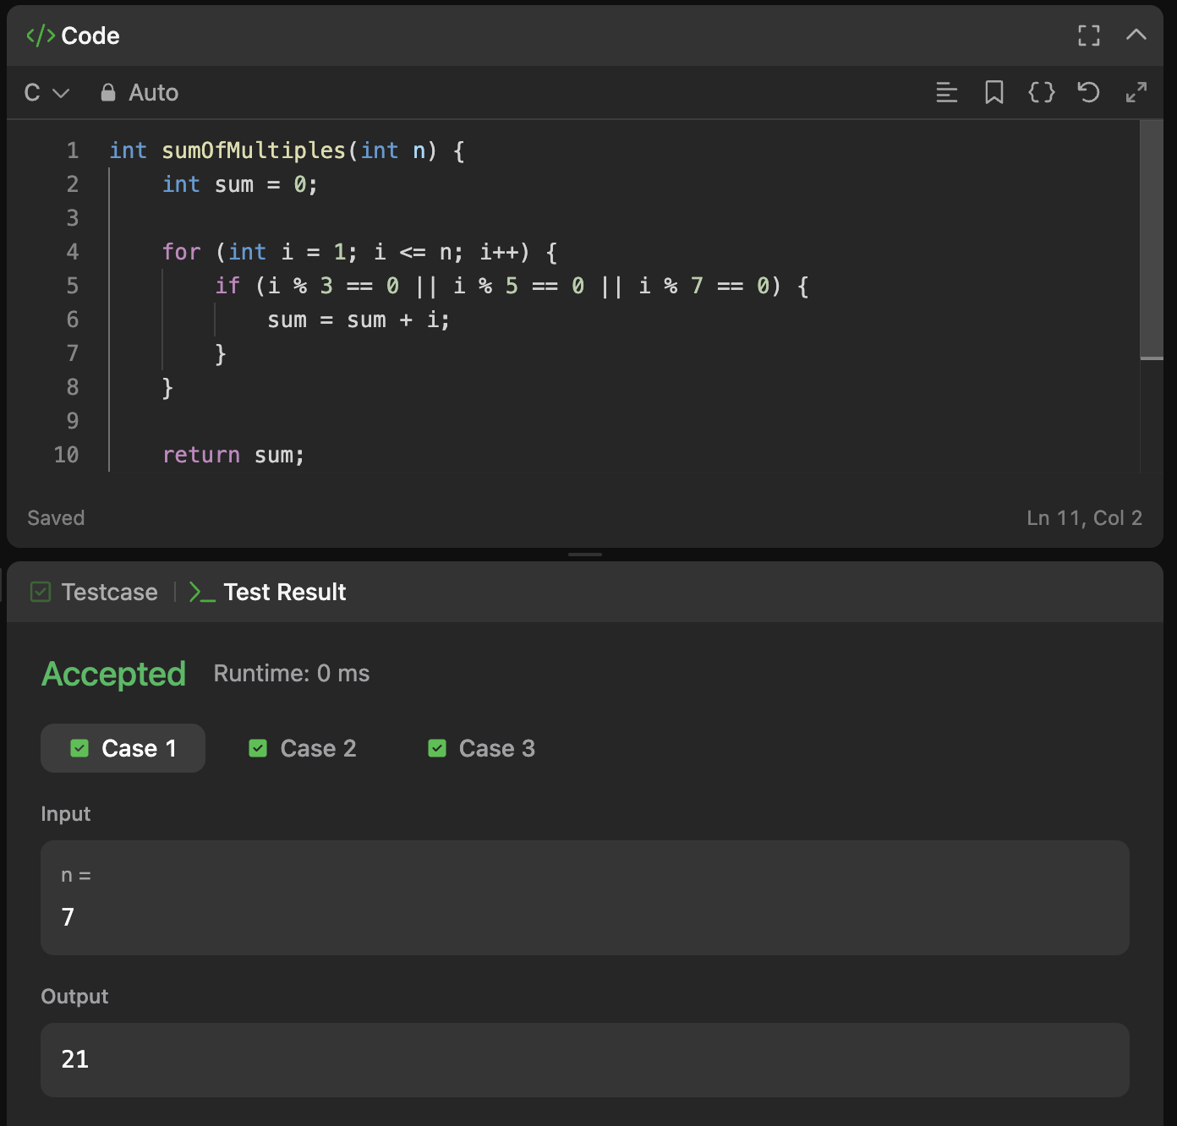

Question 6: Number Line Jumps
Platform: HackerRank
Problem link: https://www.hackerrank.com/challenges/kangaroo/problem
C Code
char* kangaroo(int x1, int v1, int x2, int v2)
{
if(v1 == v2)
return x1 == x2 ? "YES" : "NO";
if((x2 - x1) % (v1 - v2) == 0 &&
(x2 - x1) / (v1 - v2) >= 0)
return "YES";
return "NO";
}
Successful Submission Screenshot


Module 4 — Digit extraction and number manipulation

Question 1: Digit Sum
Platform: HackerEarth
Problem link: https://www.hackerearth.com/problem/algorithm/digit-sum-4/
C Code
#include <stdio.h>
int main()
{
int n, sum = 0;
scanf("%d", &n);
while(n > 0)
{
sum += n % 10;
n /= 10;
}
printf("%d\n", sum);
return 0;
}
Successful Submission Screenshot
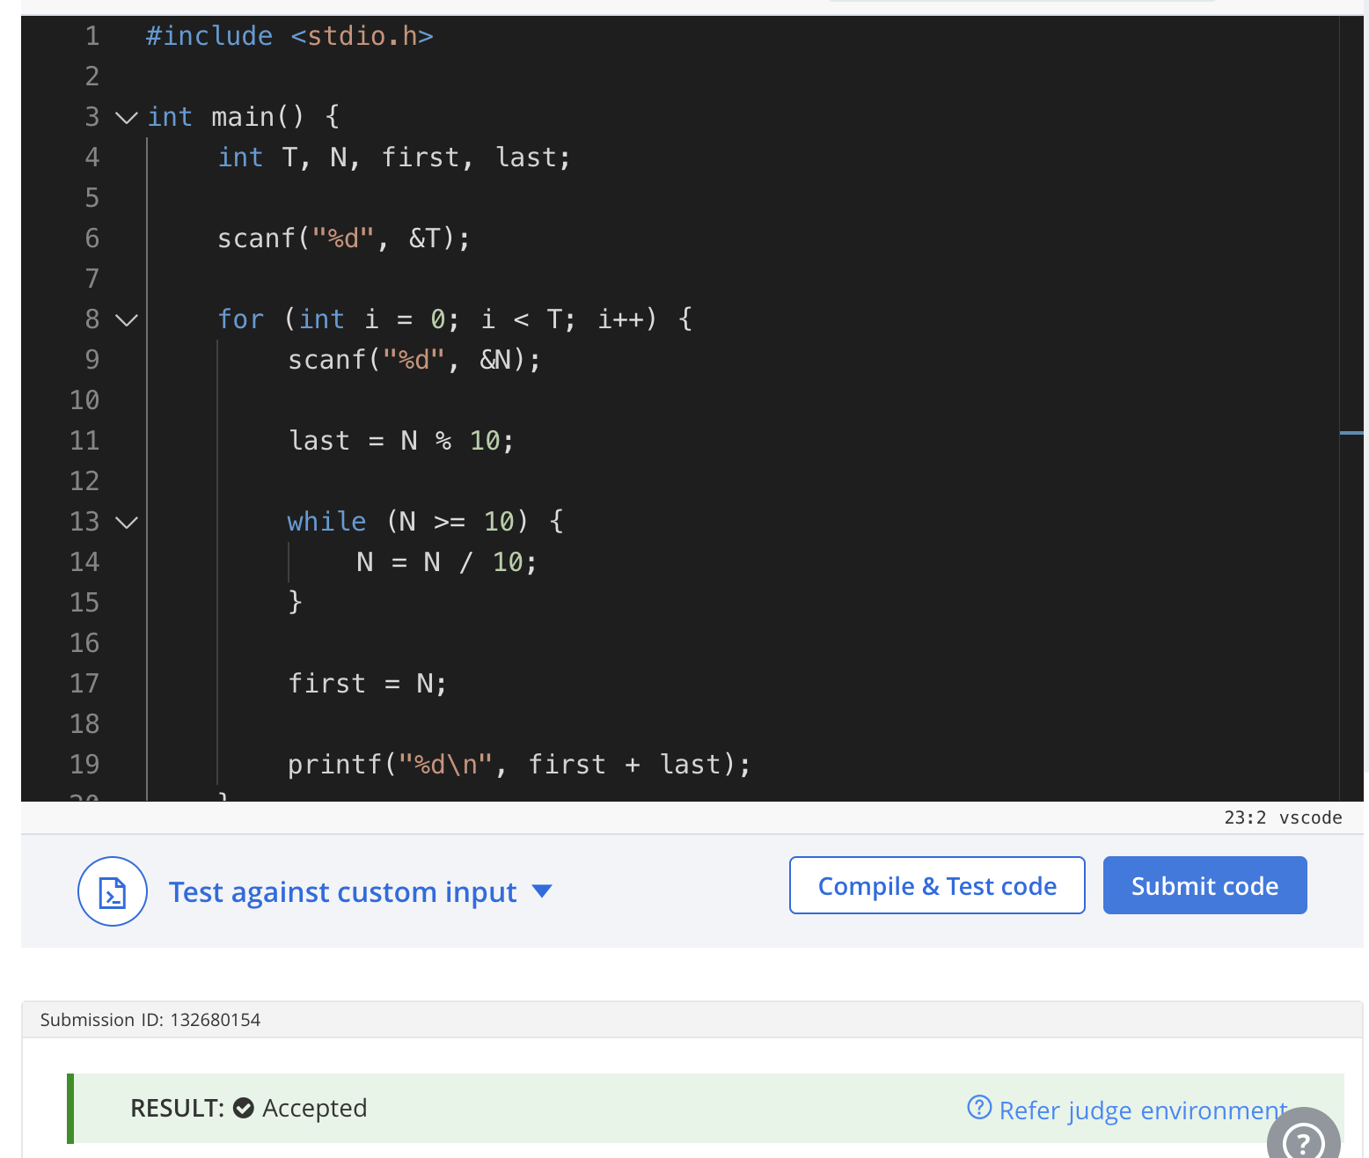

Question 2: Find Digits
Platform: HackerRank
Problem link: https://www.hackerrank.com/challenges/find-digits/problem
C Code
int findDigits(int n)
{
int original = n, count = 0;
while(n > 0)
{
int digit = n % 10;
if(digit != 0 && original % digit == 0) count++;
n /= 10;
}
return count;
}
Successful Submission Screenshot
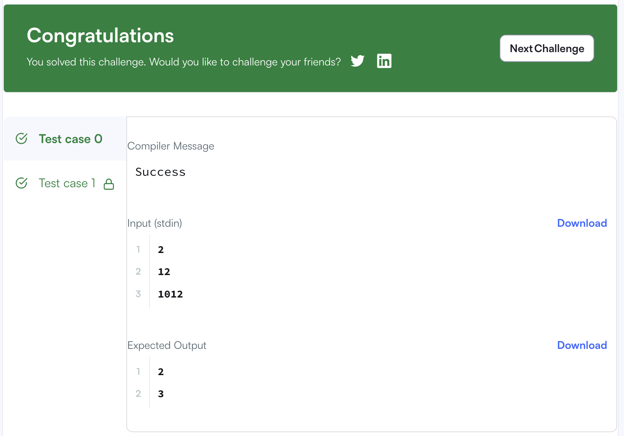

Question 3: 1281 — Subtract the Product and Sum of Digits
Platform: LeetCode
Problem link: https://leetcode.com/problems/subtract-the-product-and-sum-of-digits-of-an-integer/
C Code
int subtractProductAndSum(int n)
{
int product = 1, sum = 0;
while(n > 0)
{
int digit = n % 10;
product *= digit;
sum += digit;
n /= 10;
}
return product - sum;
}
Successful Submission Screenshot
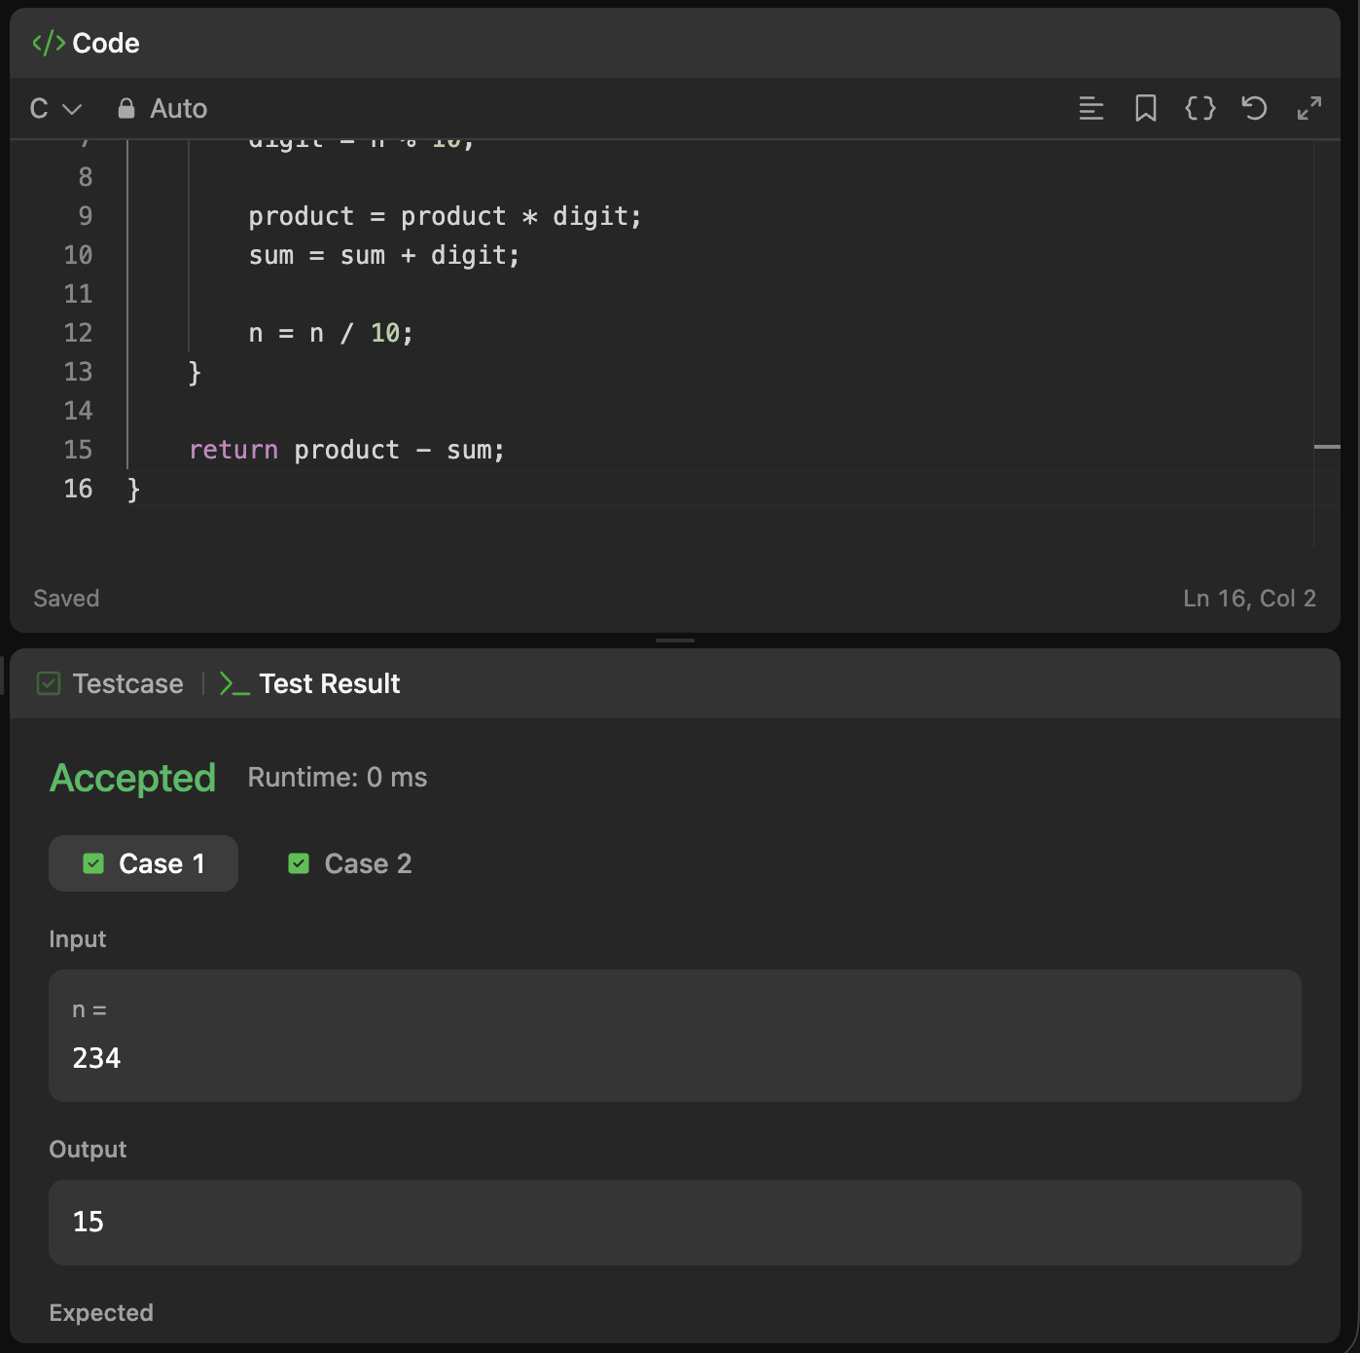

Question 4: 2520 — Count the Digits That Divide a Number
Platform: LeetCode
Problem link: https://leetcode.com/problems/count-the-digits-that-divide-a-number/
C Code
int countDigits(int num)
{
int n = num, count = 0;
while(n > 0)
{
int d = n % 10;
if(d != 0 && num % d == 0) count++;
n /= 10;
}
return count;
}
Successful Submission Screenshot
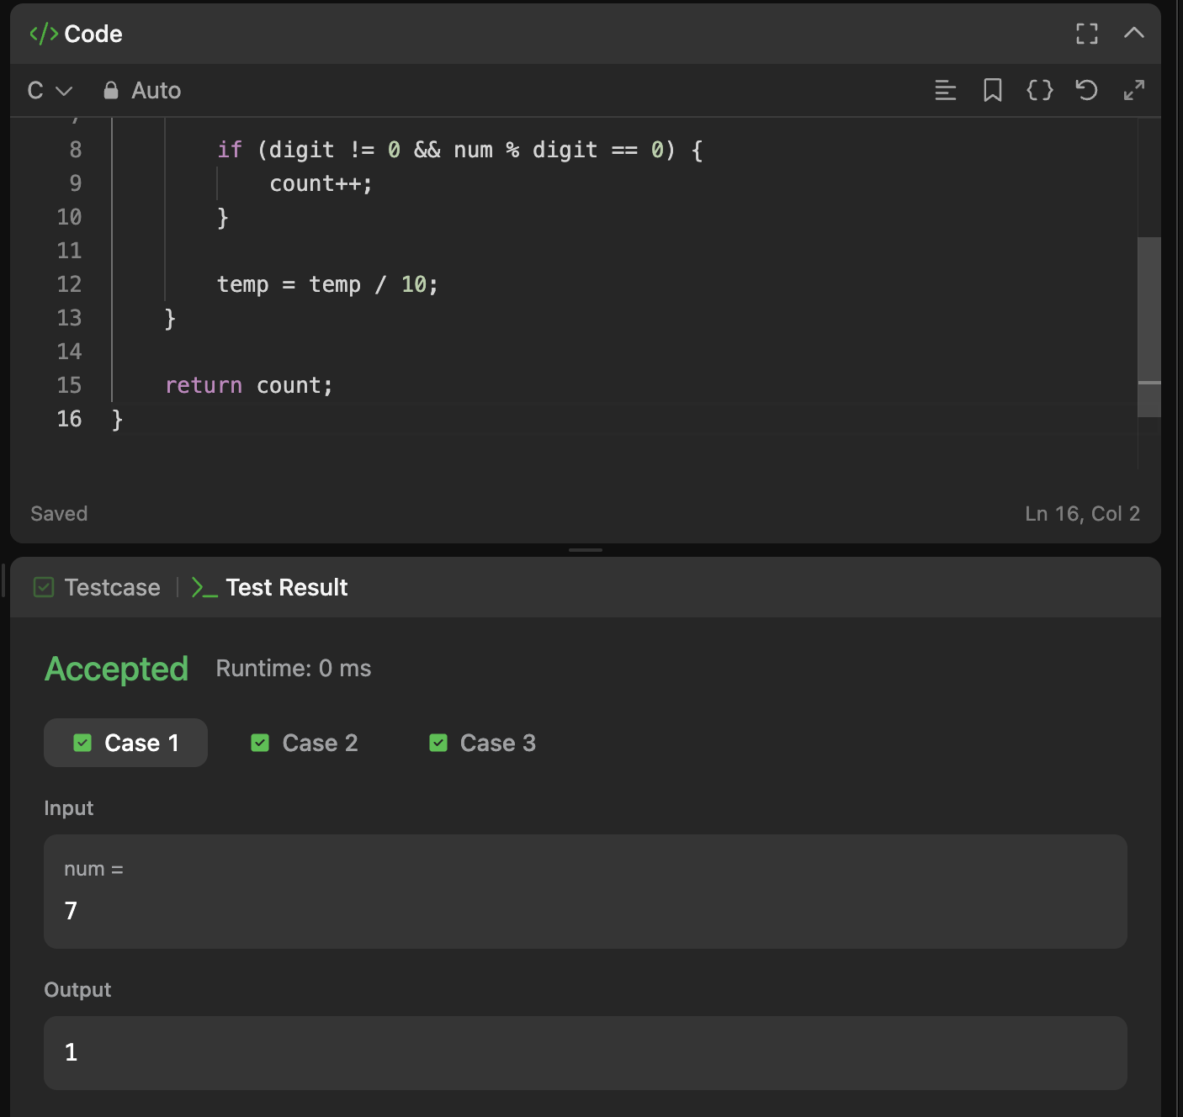

Question 5: 9 — Palindrome Number
Platform: LeetCode
Problem link: https://leetcode.com/problems/palindrome-number/
C Code
bool isPalindrome(int x)
{
if(x < 0) return false;
long long reverse = 0;
int n = x;
while(n > 0)
{
reverse = reverse * 10 + n % 10;
n /= 10;
}
return reverse == x;
}
Successful Submission Screenshot
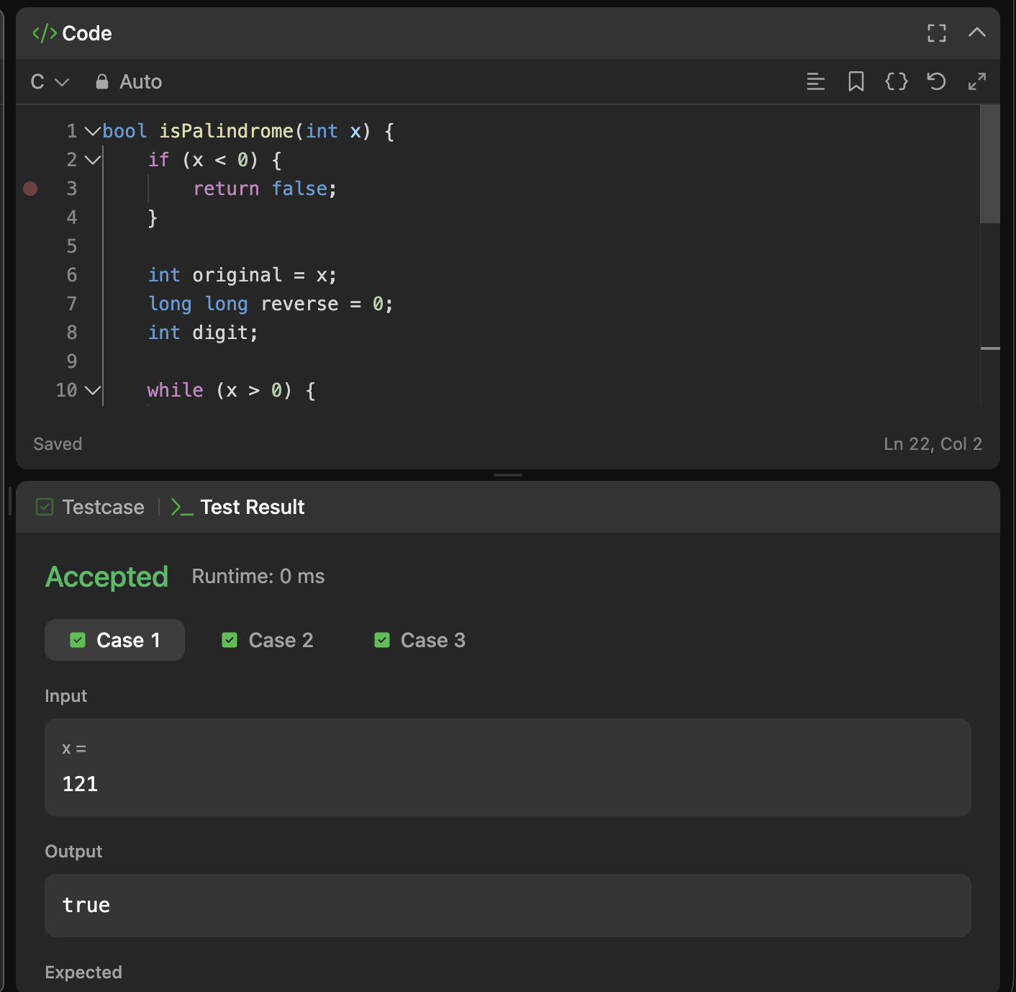

Question 6: 7 — Reverse Integer
Platform: LeetCode
Problem link: https://leetcode.com/problems/reverse-integer/
C Code
#include <limits.h>
int reverse(int x)
{
long long result = 0;
while(x != 0)
{
result = result * 10 + x % 10;
x /= 10;
}
if(result > INT_MAX || result < INT_MIN) return 0;
return (int)result;
}
Successful Submission Screenshot
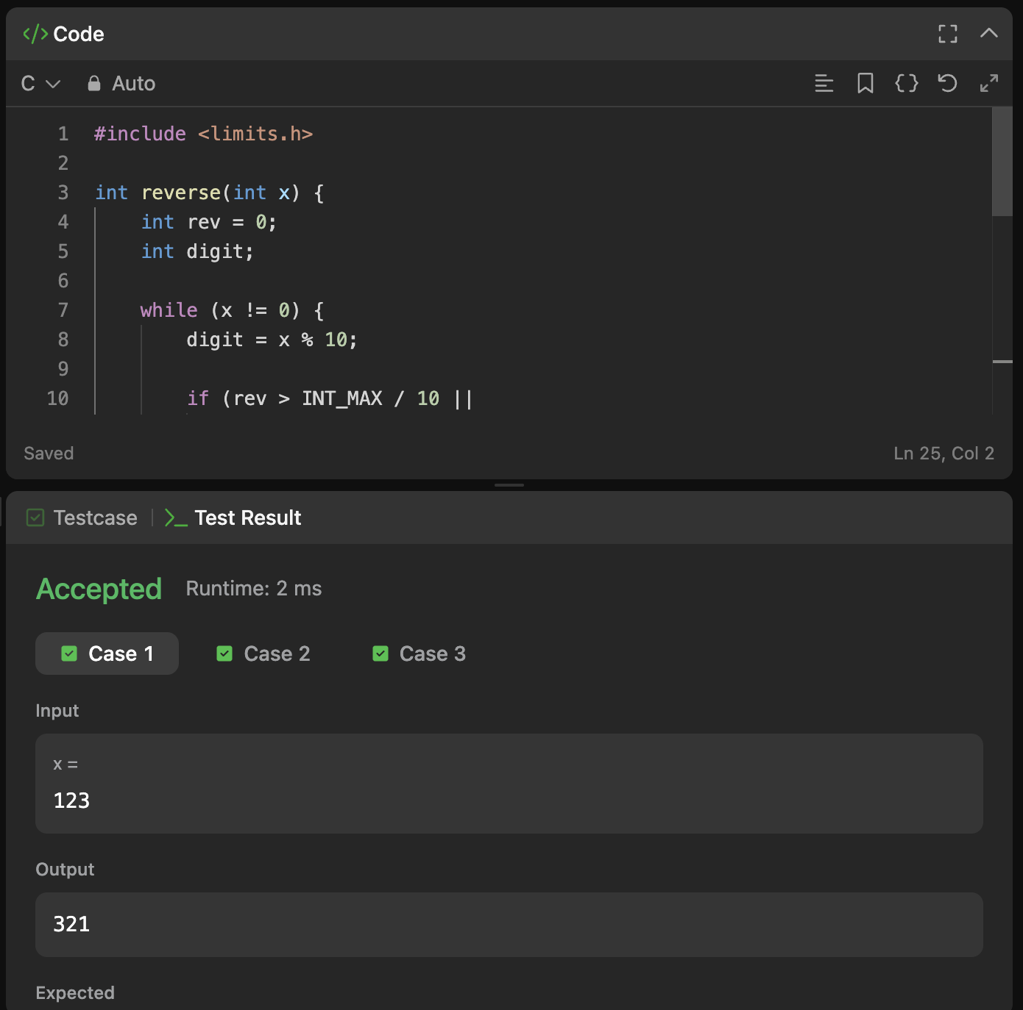

Module 5 — Factors, divisibility and mathematical loops

Question 1: 231 — Power of Two
Platform: LeetCode
Problem link: https://leetcode.com/problems/power-of-two/
C Code
bool isPowerOfTwo(int n)
{
if(n <= 0) return false;
while(n % 2 == 0) n /= 2;
return n == 1;
}
Successful Submission Screenshot
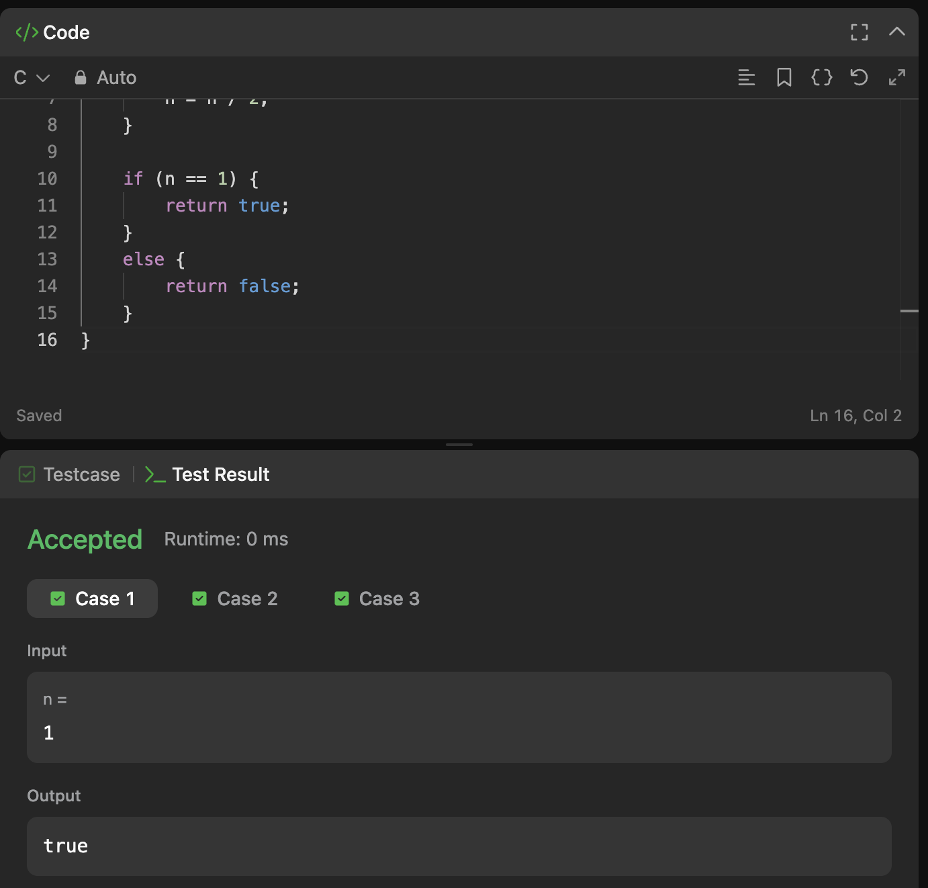

Question 2: 326 — Power of Three
Platform: LeetCode
Problem link: https://leetcode.com/problems/power-of-three/
C Code
bool isPowerOfThree(int n)
{
if(n <= 0) return false;
while(n % 3 == 0) n /= 3;
return n == 1;
}
Successful Submission Screenshot
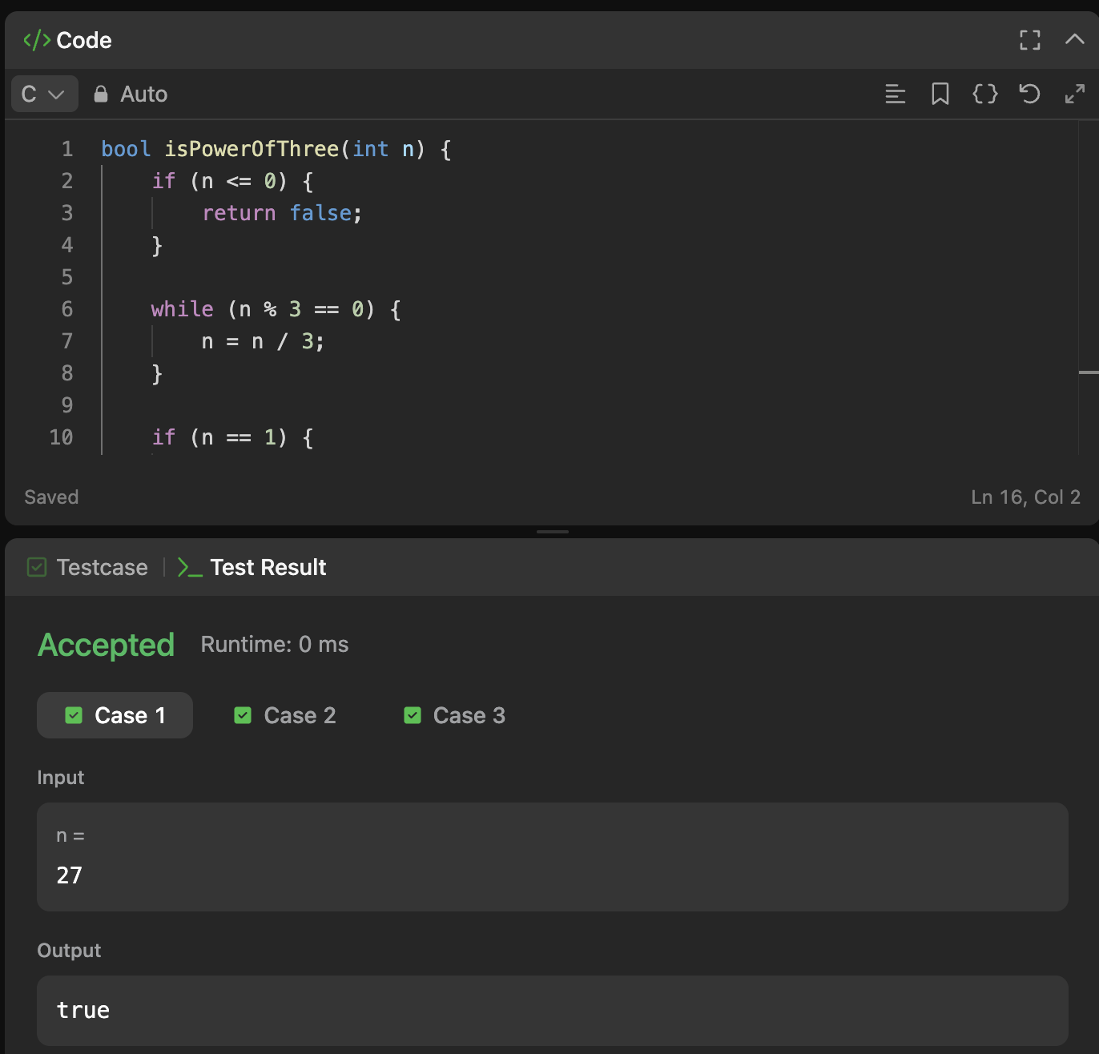

Question 3: Factorial!
Platform: HackerEarth
Problem link: https://www.hackerearth.com/practice/basic-programming/input-output/basics-of-input-output/practice-problems/algorithm/find-factorial/
C Code
#include <stdio.h>
int main()
{
int n;
long long fact = 1;
scanf("%d", &n);
for(int i = 1; i <= n; i++) fact *= i;
printf("%lld\n", fact);
return 0;
}
Successful Submission Screenshot
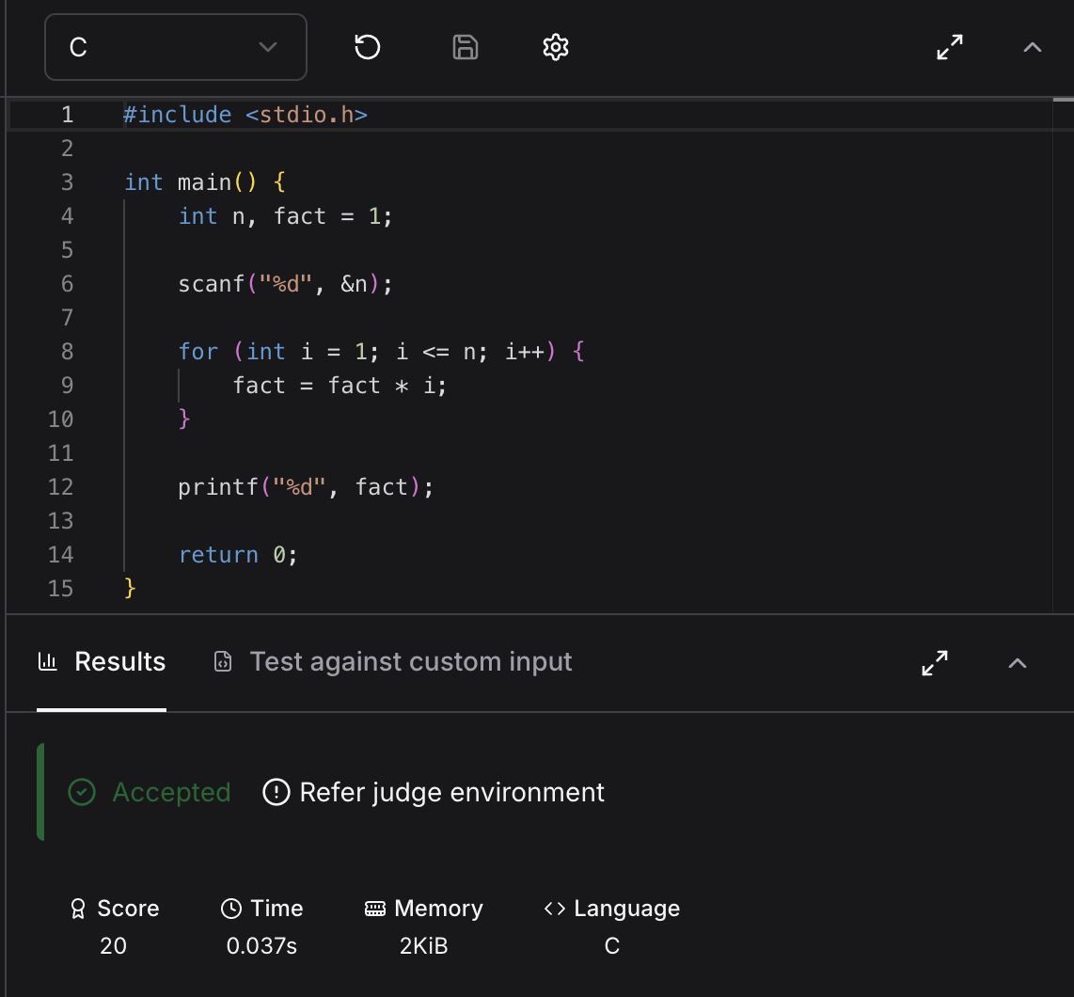

Question 4: Count Divisors
Platform: HackerEarth
Problem link: https://www.hackerearth.com/practice/basic-programming/input-output/basics-of-input-output/practice-problems/algorithm/count-divisors/
C Code
#include <stdio.h>
int main()
{
int l, r, k, count = 0;
scanf("%d %d %d", &l, &r, &k);
for(int i = l; i <= r; i++)
if(i % k == 0) count++;
printf("%d\n", count);
return 0;
}
Successful Submission Screenshot
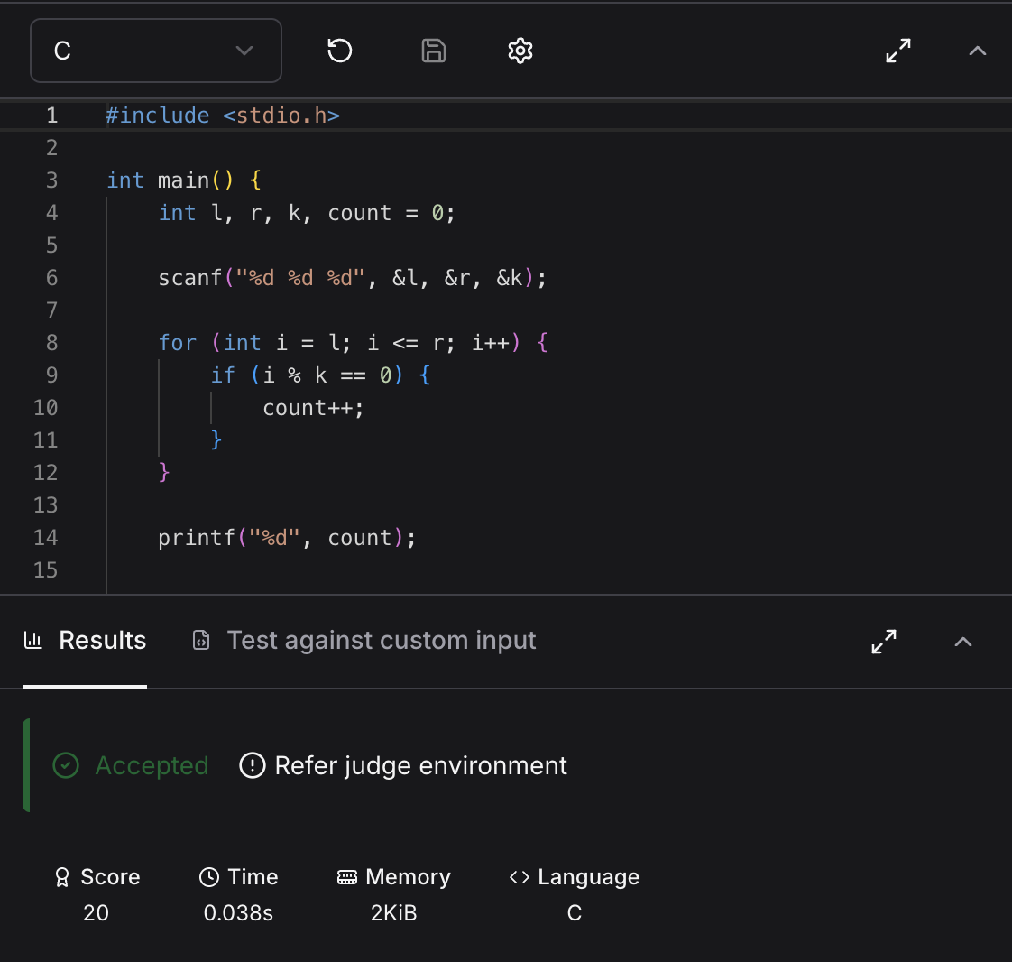

Question 5: Prime Numbers
Platform: HackerEarth
Problem link: https://www.hackerearth.com/problem/algorithm/prime-numbers/
C Code
#include <stdio.h>
int main()
{
int n;
scanf("%d", &n);
for(int i = 2; i <= n; i++)
{
int prime = 1;
for(int j = 2; j * j <= i; j++)
{
if(i % j == 0) { prime = 0; break; }
}
if(prime) printf("%d ", i);
}
return 0;
}
Successful Submission Screenshot
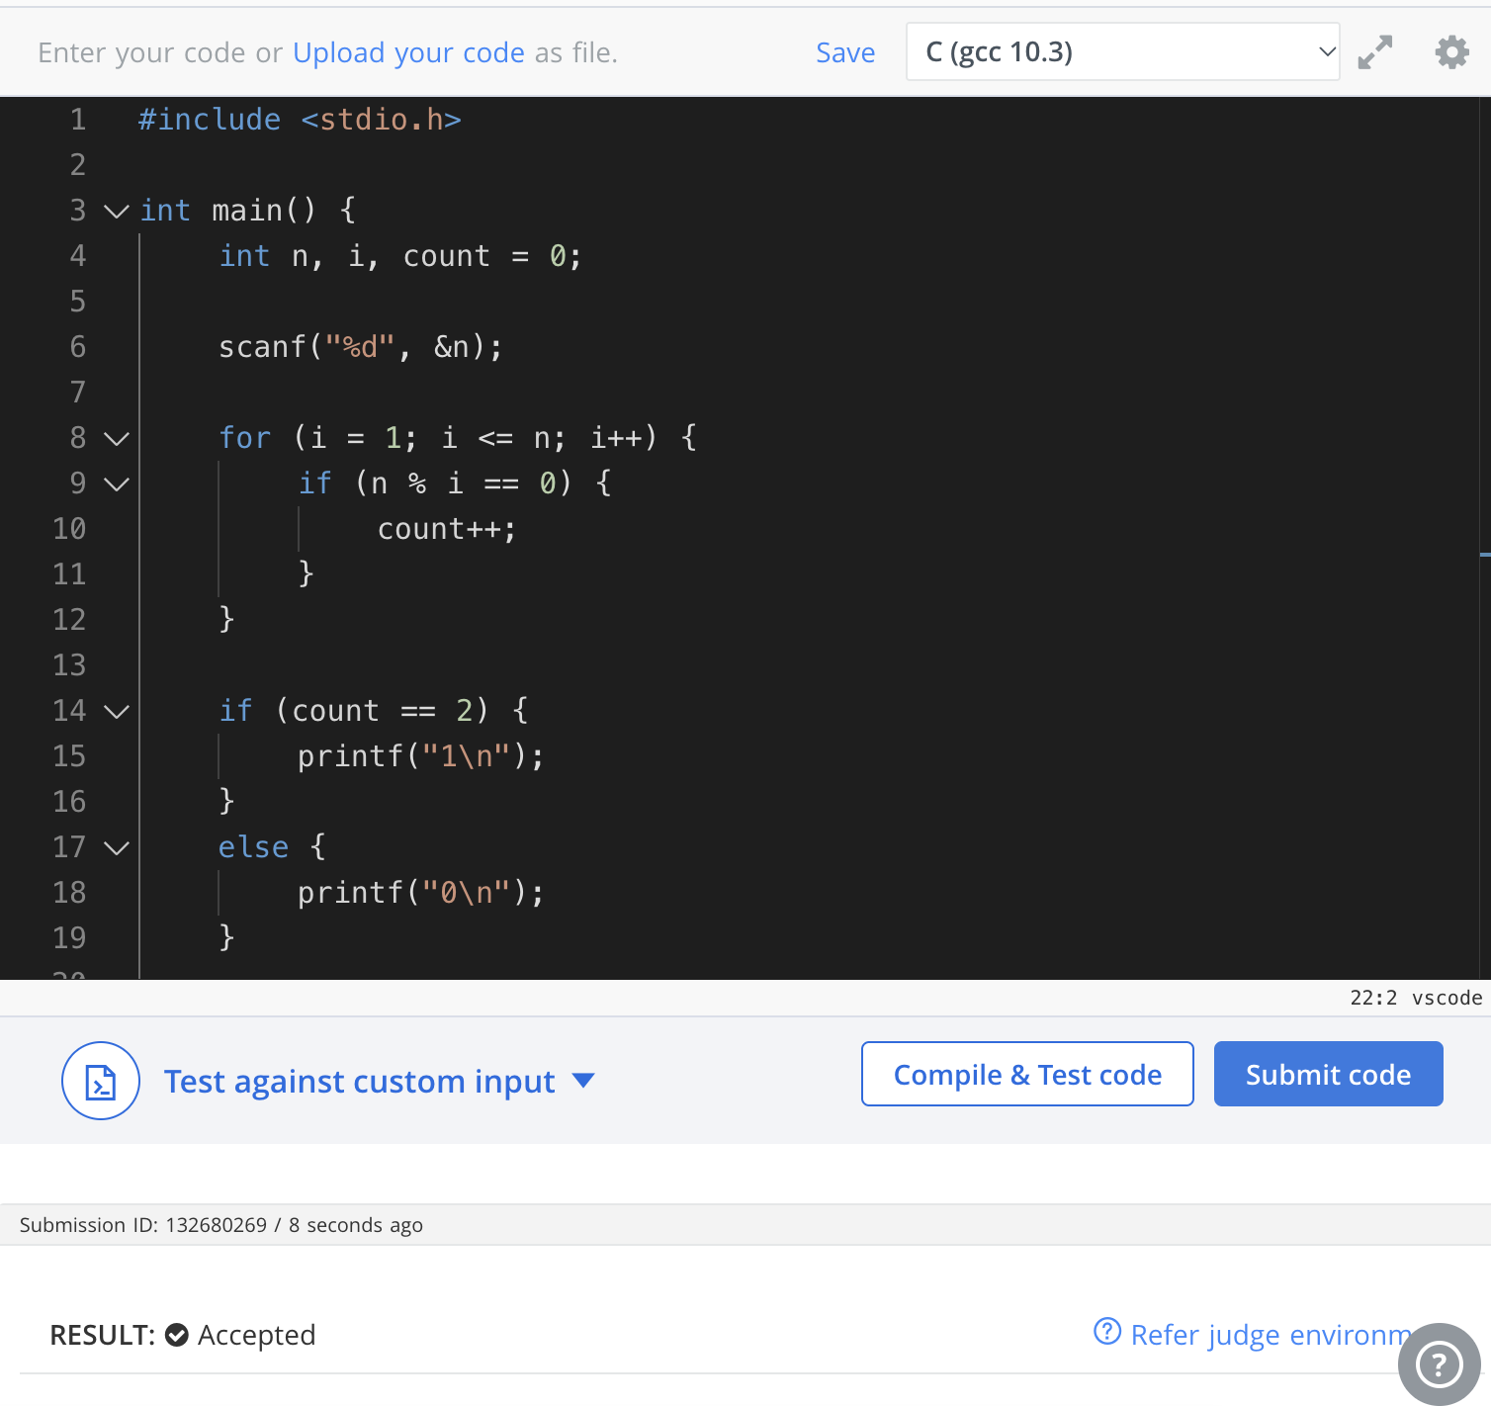

Question 6: 507 — Perfect Number
Platform: LeetCode
Problem link: https://leetcode.com/problems/perfect-number/
C Code
bool checkPerfectNumber(int num)
{
if(num <= 1) return false;
int sum = 1;
for(int i = 2; i <= num / i; i++)
{
if(num % i == 0)
{
sum += i;
if(i != num / i) sum += num / i;
}
}
return sum == num;
}
Successful Submission Screenshot
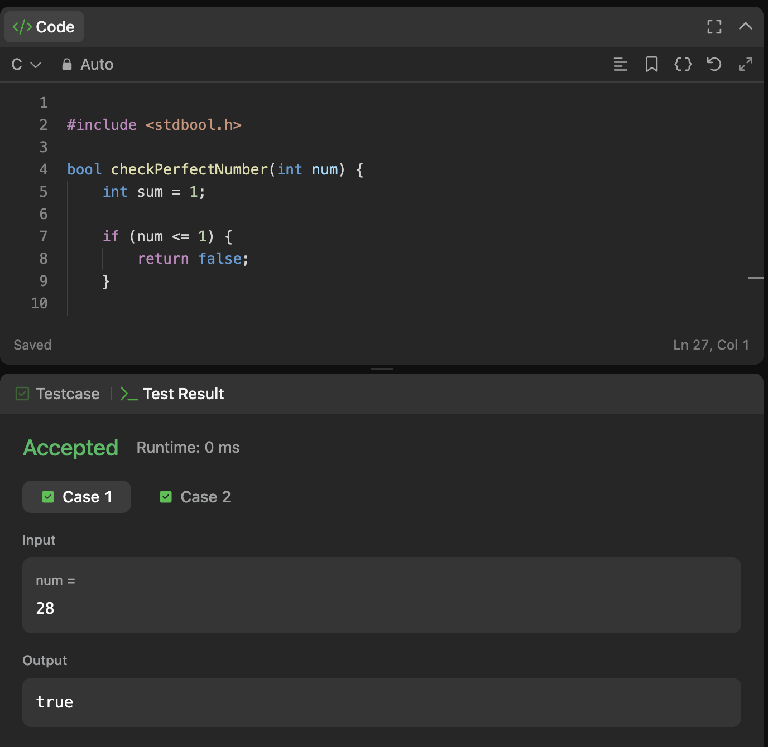

Module 6 — Nested loops: online judge problems

Question 1: Staircase
Platform: HackerRank
Problem link: https://www.hackerrank.com/challenges/staircase/problem
C Code
void staircase(int n)
{
for(int i = 1; i <= n; i++)
{
for(int j = 1; j <= n - i; j++) printf(" ");
for(int j = 1; j <= i; j++) printf("#");
printf("\n");
}
}
Successful Submission Screenshot


Question 2: Printing Pattern Using Loops
Platform: HackerRank
Problem link: https://www.hackerrank.com/challenges/printing-pattern-2/problem
C Code
#include <stdio.h>
int main()
{
int n;
scanf("%d", &n);
int size = 2 * n - 1;
for(int i = 0; i < size; i++)
{
for(int j = 0; j < size; j++)
{
int top = i, left = j;
int bottom = size - 1 - i, right = size - 1 - j;
int layer = top;
if(bottom < layer) layer = bottom;
if(left < layer) layer = left;
if(right < layer) layer = right;
printf("%d", n - layer);
if(j < size - 1) printf(" ");
}
printf("\n");
}
return 0;
}
Successful Submission Screenshot


